Aim: To understand the process of convolution over the image and apply over the classification problem
IDE: Google Colab

Theory:
Convolutional Neural Networks (CNN) are complex feed forward neural networks. CNNs are used for image classification and recognition because of its high accuracy There are three types of layers in a convolutional neural network: i. Convolutional layer ii. Pooling layer iii. Fully connected layer Each of these layers has different parameters that can be optimized and performs a different task on the input data.

What is Pooling Layer?
Pooling layer is responsible for reducing the spatial size of the Convolved Feature. This is to decrease the computational power required to process the data through dimensionality reduction. There are two types of Pooling i. Average Pooling. ii. Max Pooling Max Pooling returns the maximum value from the portion of the image covered by the Kernel. On the other hand, Average Pooling returns the average of all the values from the portion of the image covered by the Kernel. Max Pooling also performs as a Noise Suppressant. It discards the noisy activations altogether and also performs de-noising along with dimensionality reduction. On the other hand, Average Pooling simply performs dimensionality reduction as a noise suppressing mechanism. Hence, we can say that Max Pooling performs a lot better than Average Pooling.

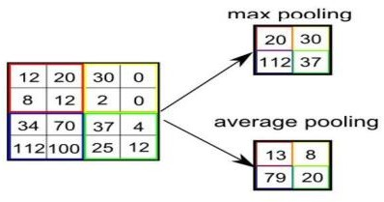

What is Convolutional Layer?
Convolutional layers are the major building blocks used in convolutional neural networks. A convolution is the simple application of a filter to an input that results in an activation. Repeated application of the same filter to an input results in a map of activations called a feature map, indicating the locations and strength of a detected feature in an input, such as an image. A convolutional layer contains a set of filters whose parameters need to be learned. The height and weight of the filters are smaller than those of the input volume. Each filter is convolved with the input volume to compute an activation map made of neurons.

What is Fully Connected Layer?
A fully connected layer that takes the output of convolution/pooling and predicts the best label to describe the image We have three layers in the full connection step i. Input layer ii. Fully-connected layer iii. Output layer

Input Layer: It takes the output of the previous layers, “flattens” them and turns them into a single vector that can be an input for the next stage.

Fully Connected Layer: It takes the inputs from the feature analysis and applies weights to predict the correct label.

Output Layer: It gives the final probabilities for each label.
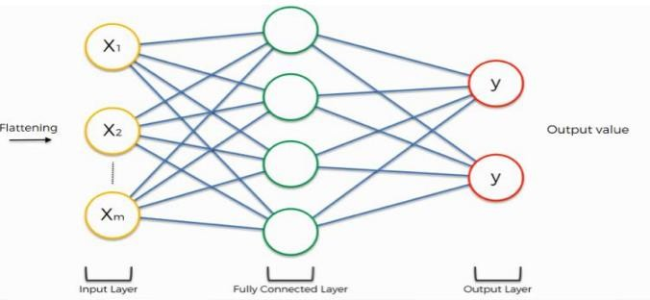

ReLU Layer: ReLU is an activation function. Rectified Linear Unit (ReLU) transform function only activates a node if the input is above a certain quantity, while the input is below zero, the output is zero, but when the input rises above a certain threshold, it has a linear relationship with the dependent variable. The main aim is to remove all the negative values from the convolution. All the positive values remain the same but all the negative values get changed to zero.

Methodology:
- Load the basic libraries and packages
- Load the dataset
- Analyse the dataset
- Normalize the data
- Pre-process the data
- Visualize the Data

- Write the CNN model function
- Write the Cost Function
- Write the Gradient Descent optimization algorithm
- Apply the training over the dataset to minimize the loss
- Observe the cost function vs iterations learning curve

Program (Code):
#lab 4

# Step 1: Import Libraries
import tensorflow as tf
from tensorflow.keras import layers, models
import matplotlib.pyplot as plt

# Step 2: Load Dataset (MNIST)
(X_train, y_train), (X_test, y_test) = tf.keras.datasets.mnist.load_data()

# Step 3: Normalize Data
X_train = X_train / 255.0
X_test = X_test / 255.0

# Step 4: Reshape (for CNN)
X_train = X_train.reshape(-1, 28, 28, 1)
X_test = X_test.reshape(-1, 28, 28, 1)

# Step 5: CNN Model (Without Regularization)
model = models.Sequential([
layers.Conv2D(32, (3,3), activation='relu', input_shape=(28,28,1)),
layers.MaxPooling2D((2,2)),
layers.Conv2D(64, (3,3), activation='relu'),
layers.MaxPooling2D((2,2)),
layers.Flatten(),
layers.Dense(64, activation='relu'),
layers.Dense(10, activation='softmax')
])

model.compile(optimizer='adam',
loss='sparse_categorical_crossentropy',
metrics=['accuracy'])

# Step 6: Train Model
history = model.fit(X_train, y_train, epochs=5,
validation_data=(X_test, y_test))

# Step 7: Model Summary
model.summary()

# Step 8: Plot Accuracy
plt.plot(history.history['accuracy'])
plt.plot(history.history['val_accuracy'])
plt.title('Accuracy vs Epochs')
plt.legend(['Train','Validation'])
plt.show()

# Step 9: Plot Loss
plt.plot(history.history['loss'])
plt.plot(history.history['val_loss'])
plt.title('Loss vs Epochs')
plt.legend(['Train','Validation'])
plt.show()

# Step 10: CNN with Regularization (Dropout)
model_reg = models.Sequential([
layers.Conv2D(32, (3,3), activation='relu', input_shape=(28,28,1)),
layers.MaxPooling2D((2,2)),
layers.Dropout(0.25),
layers.Conv2D(64, (3,3), activation='relu'),
layers.MaxPooling2D((2,2)),
layers.Dropout(0.25),
layers.Flatten(),
layers.Dense(64, activation='relu'),
layers.Dropout(0.5),
layers.Dense(10, activation='softmax')
])

model_reg.compile(optimizer='adam',
loss='sparse_categorical_crossentropy',
metrics=['accuracy'])

history_reg = model_reg.fit(X_train, y_train, epochs=5,
validation_data=(X_test, y_test))

Results:

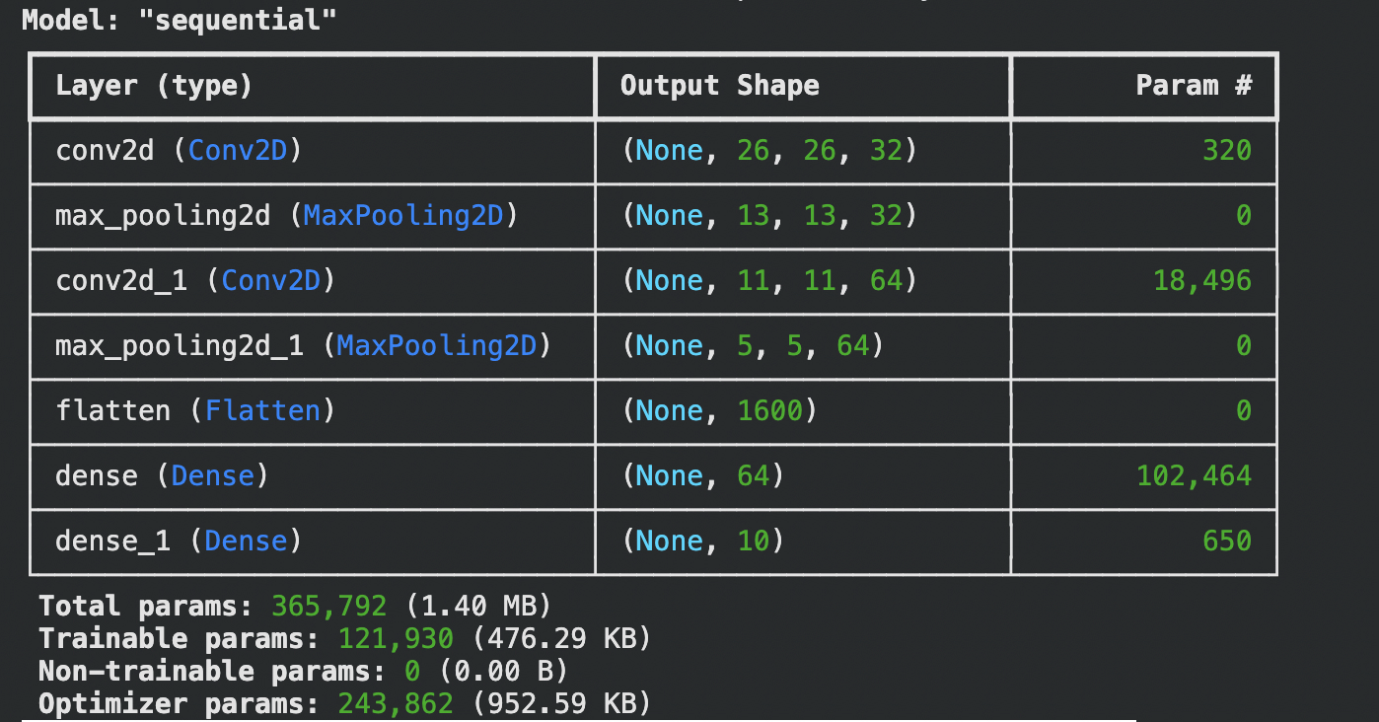

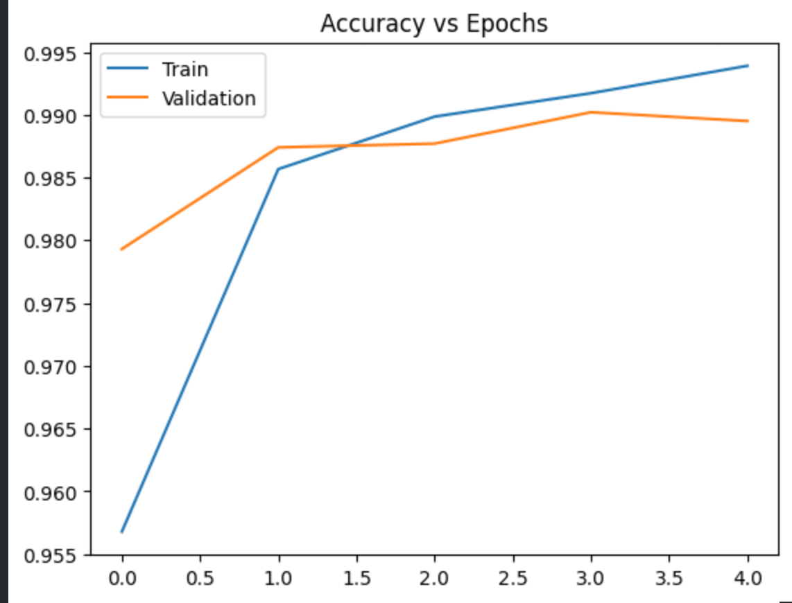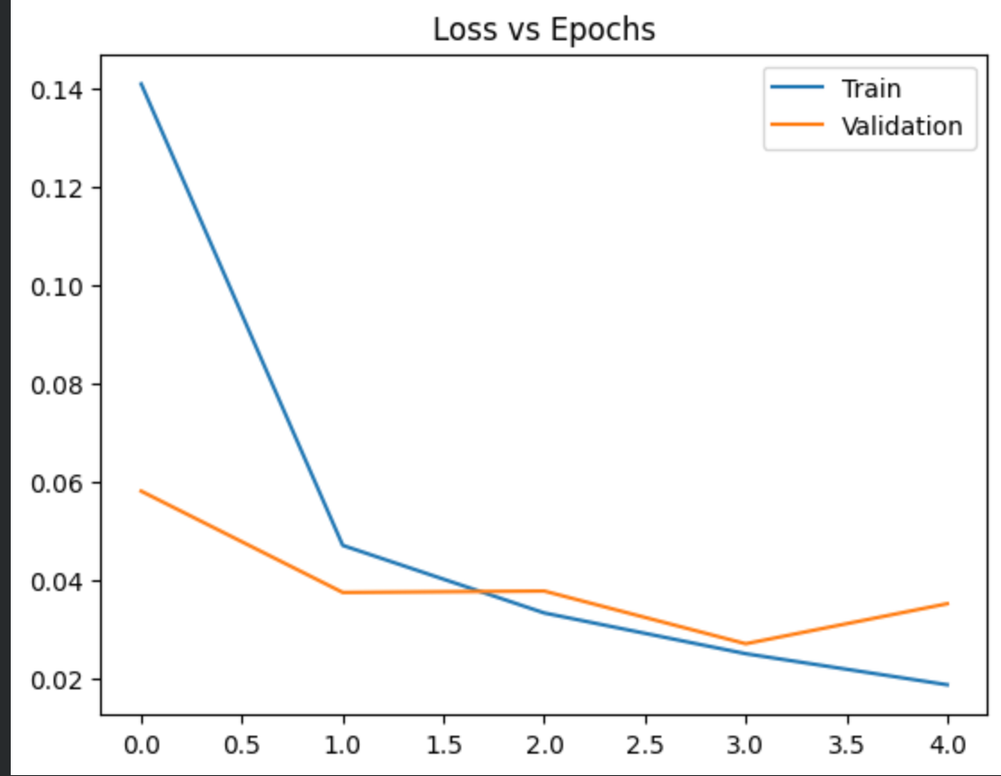

Pre Lab Exercise:
- What is Convolution process? Explain giving example.
Ans: convolution is the process of applying a filter over an image to extract features the filter slides over the image and performs element wise multiplication and summation it helps detects patterns like edges textures and shapes ex. Edge detection filter highlights boundaries in an image.

- What are different layers in CNN model?
Ans: cnn consists of convolutional, pooling and fully connected layers convolutional layer extracts features from images pooling layer reduces dimensionality and computation fully connected layer performs classification.

- What is the requirement of the pooling layer in the CNN model?
Ans: pooling reduces the spatial size of feature maps it decreases computational complexity and prevents overfitting max pooling hepls retain important features it also provides translation in variance.

- What is the requirement of the use of ReLU activation function after convolution step?
Ans: ReLU introduces non linearity into the model it converts negative values to zero and keeps positive values uncharged this helps the network learn complex patterns it also speeds up training and avoids vanishing gradient.

Observation and Result Analysis:
- Nature of the dataset
Ans: the dataset consists of graysclae image of hand written digits each image is 28x28 pixels with labeled classed 0-9 it is well structured and suitable for cnn classification patterns like edges and strokes are clearly visible.

- Training Process without regularization
Ans: model achieves high training accuracy quickly validation accuracy may fluctuate due to overfitting loss decreases rapidly during training model may memorize training data.

- After regularization in the training Process
Ans: dropout reduces overfitting by randomly disabling neurons validation accuracy improves and becomes more stable gap between training and validation reduces model generalizes better on unseen data.

- Observation over the Learning Curves
Ans: accuracy increases and loss decreases over epoches without regularization curves may diverge with regularization curves become smother indicates improved model performance and stability.

Post Lab Exercise:
- Why CNN is preferred over ANN for images
Ans: cnn captures spatial features using filters it reduces parameters compared to ann cnn automatically extracts important features ann cannot efficiently handle image data.

- Can CNN be applied over Text data? If yes, then how. If no, then why?
Ans: yes cnn can be applied to text using word embeddings convolution captures patterns like phrases or n grams used in text classification and sentiment analysis filters slide over sequences instead of images.

- What is the role of dropout layer?
Ans: dropout randomly disables neurons during training it prevents overfitting by reducing dependency on specific neurons improves model generalization acts as a regularization technique.

- What will happen if maxpooling is replaced with minpooling?
Ans: min pooling selects the smallest value from the region important features may be lost model performance may decrease noise and irrelevant features may dominate.

